Safest Solutions Workshops

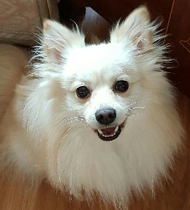Blog Post: Safest Solutions Furkidds

We are holding a workshop on how to cut your dog’s nails – this is a very important workshop as we have had numerous incidents this week with damaged dogs’ quicks. It can be a very traumatic and serious injury so please join us if you are having a problem managing this with your dog.

We offer great tips and tricks to make this a really comfortable process for the dog and you will walk away knowing how to tackle this

Please contact us to save a place for you and your furkidd!